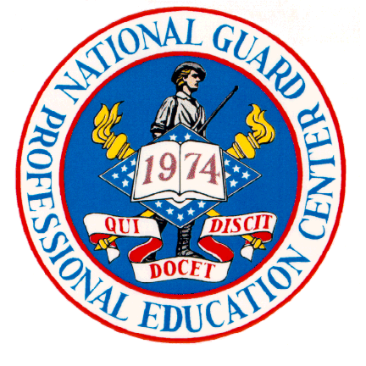

National Guard Professional Education Center
Centrally Managed Student Travel
FY 2020

Travel funds for ARNG Technicians and AGR students attending mandatory courses at NGPEC that are referenced in Memorandum ARNG-CSZ, Subject: FY20 ARNG PEC Centrally Funded Course List dated 24 September 2019, will be centrally managed by PEC Resource Management Office utilizing the cross organizational function of the Defense Travel System (DTS). Line of Accounting will be emailed to students having reserved seats in ATRRS thirty days prior to class start date.

NGPEC School Code 922/964 courses for which travel funds are centrally managed at PEC are attached.

Following information applies to students training at PEC:
- Government billets are furnished at no cost. Provide a copy of travel authorization to PEC Registration upon check in.
- Students are entitled to full per diem as government meals are not available. Per diem is $50.00 a day plus $5.00 incidentals ($55.00).
- Transportation is provided. Rental cars not authorized.

Students may create their authorization in DTS any time after securing a reservation in ATRRS. Students should type the ATRRS course number and “PEC funded” in DTS Trip Description block. When DTS approvers see this comment, they should not approve the authorization until the PEC line of accounting has been sent and selected. Students will receive email notification of LOA Cross Org prior to class start date. Questions on DTS orders should be addressed to your local DTA.
